**Assignment 5.3**

We have a dataset of movie data analysis Column Name: Column 1: User ID Column 2: Movie ID Column 3: Rating Column 4: Time stamp. The input file can be downloaded from the below link Movie data analysis

Problem statement 1: Find the number of ratings given by each user.

Problem statement 2: Find the number of ratings received by each movie.

**Program:**

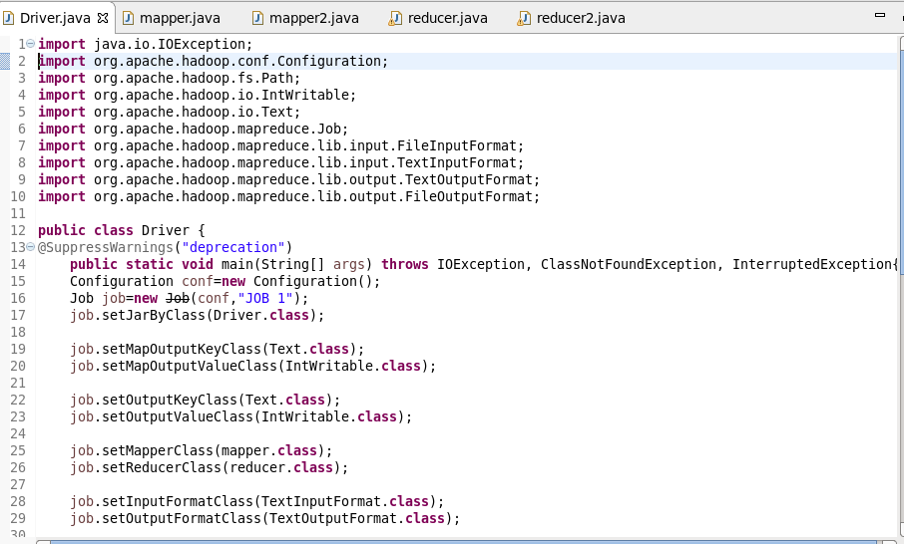

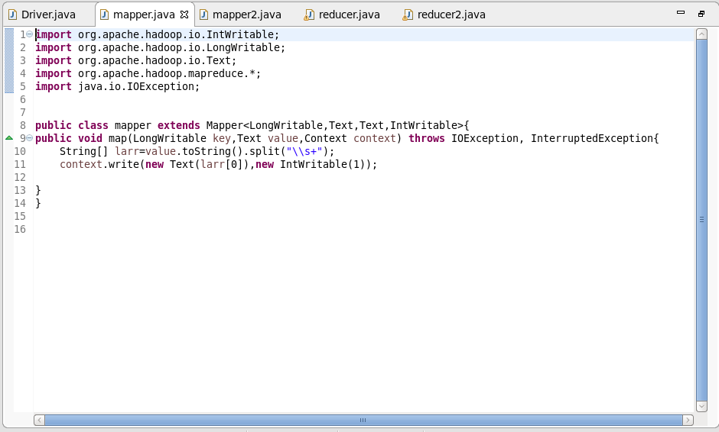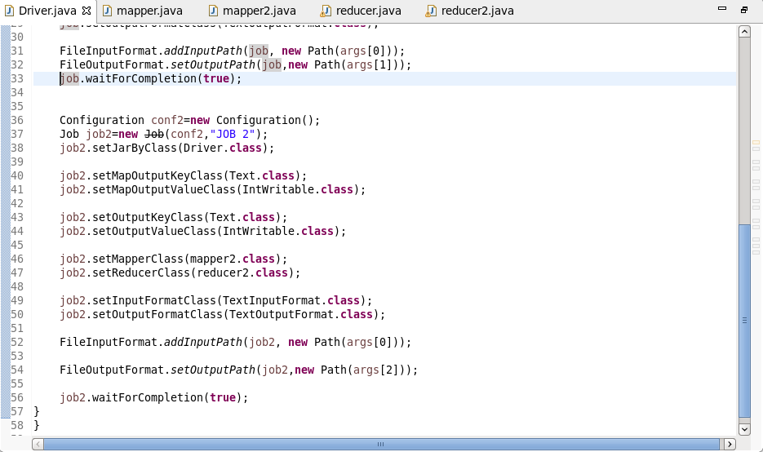

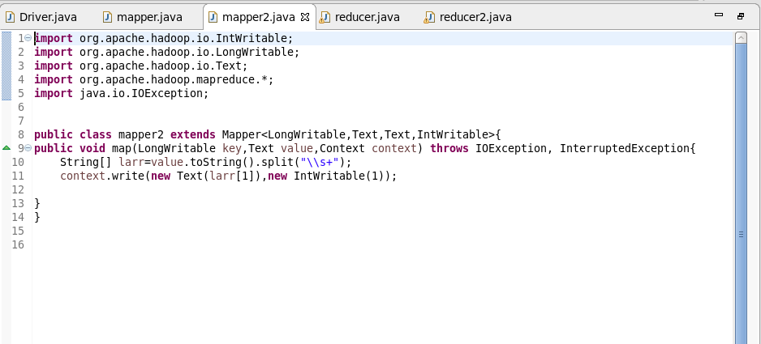

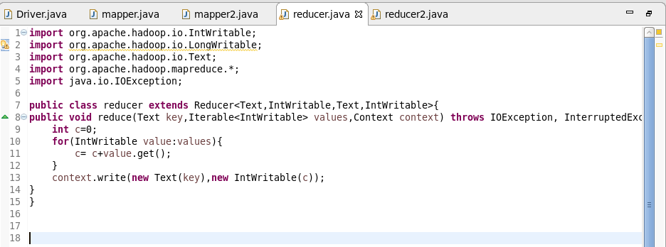

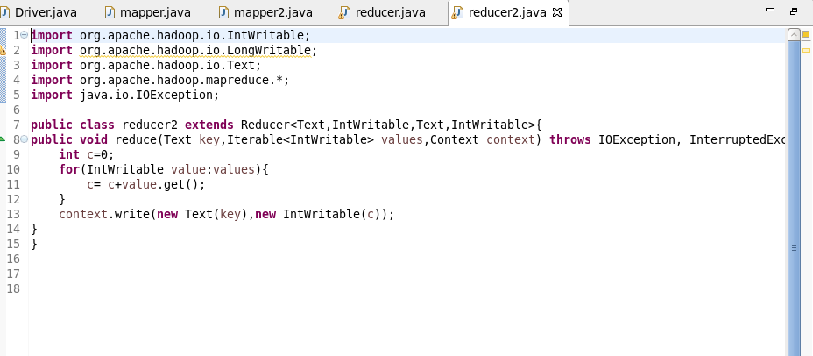

**Output:**

